Project Functionality:
The purpose of this project was to create a user friendly, interactive dashboard for Grazioso Salvare. This will allow GS to ID and categorize animals for animal rescue programs.
The program includes interactive filtering through radio buttons so Grazioso Salvare can find animals based on the following categories showcased in the screenshots below including Water Rescue, Wilderness Rescue, and Disaster/Individual Tracking.
The Dashboard is a sortable, filterable table which shows real-time results and locations from the MongoDB database.
There is also a pie chart that updates based on the filter selected, representing breeds.
There is also geolocation mapping which is a
Leaflet map with shows the last known location of a selected animal in the table.
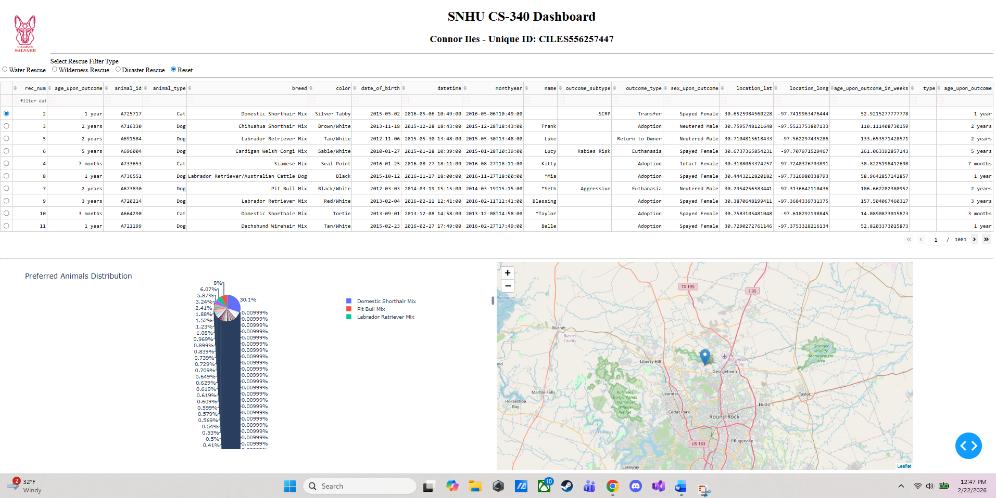
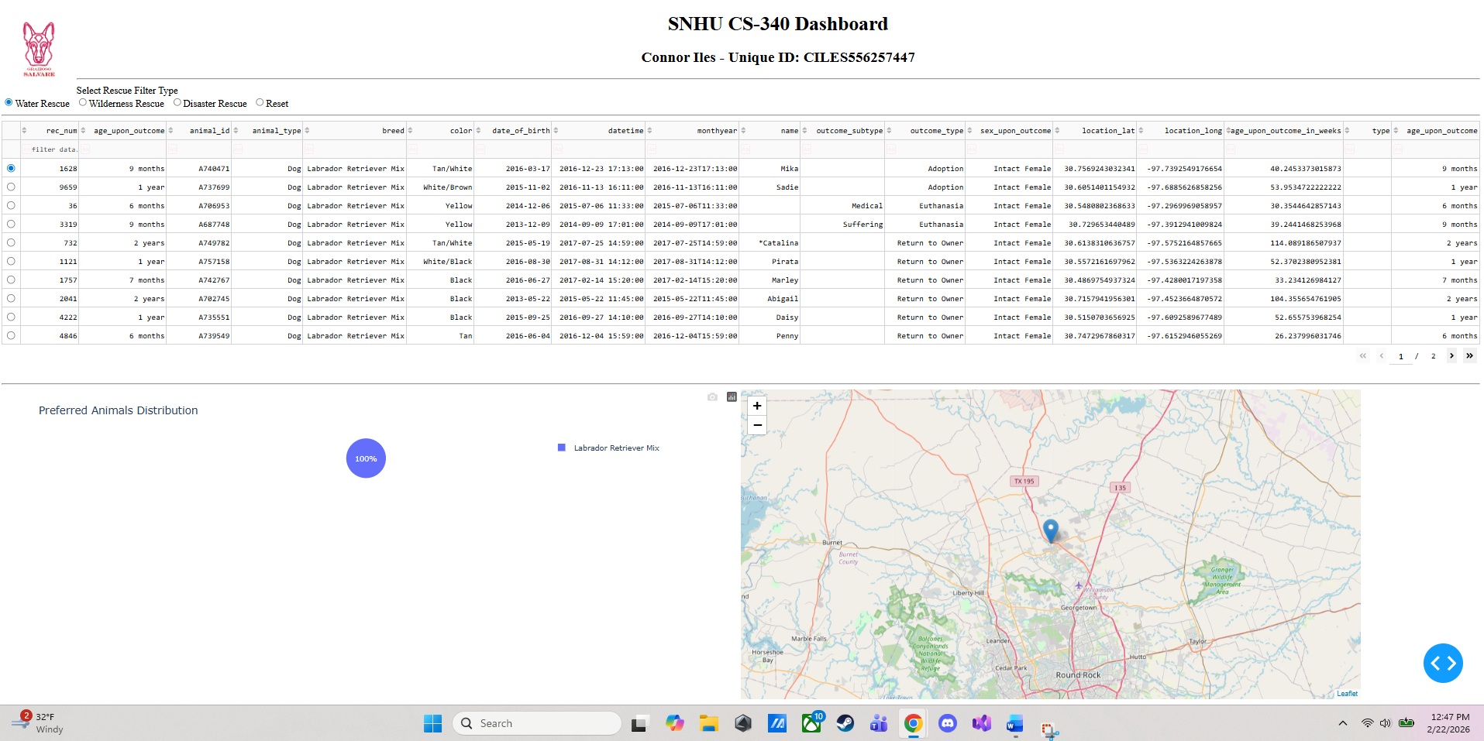
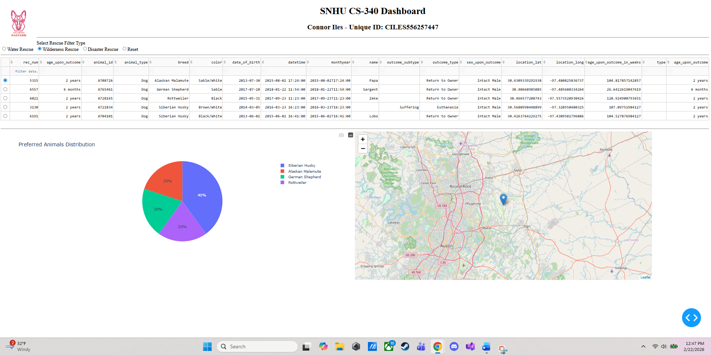
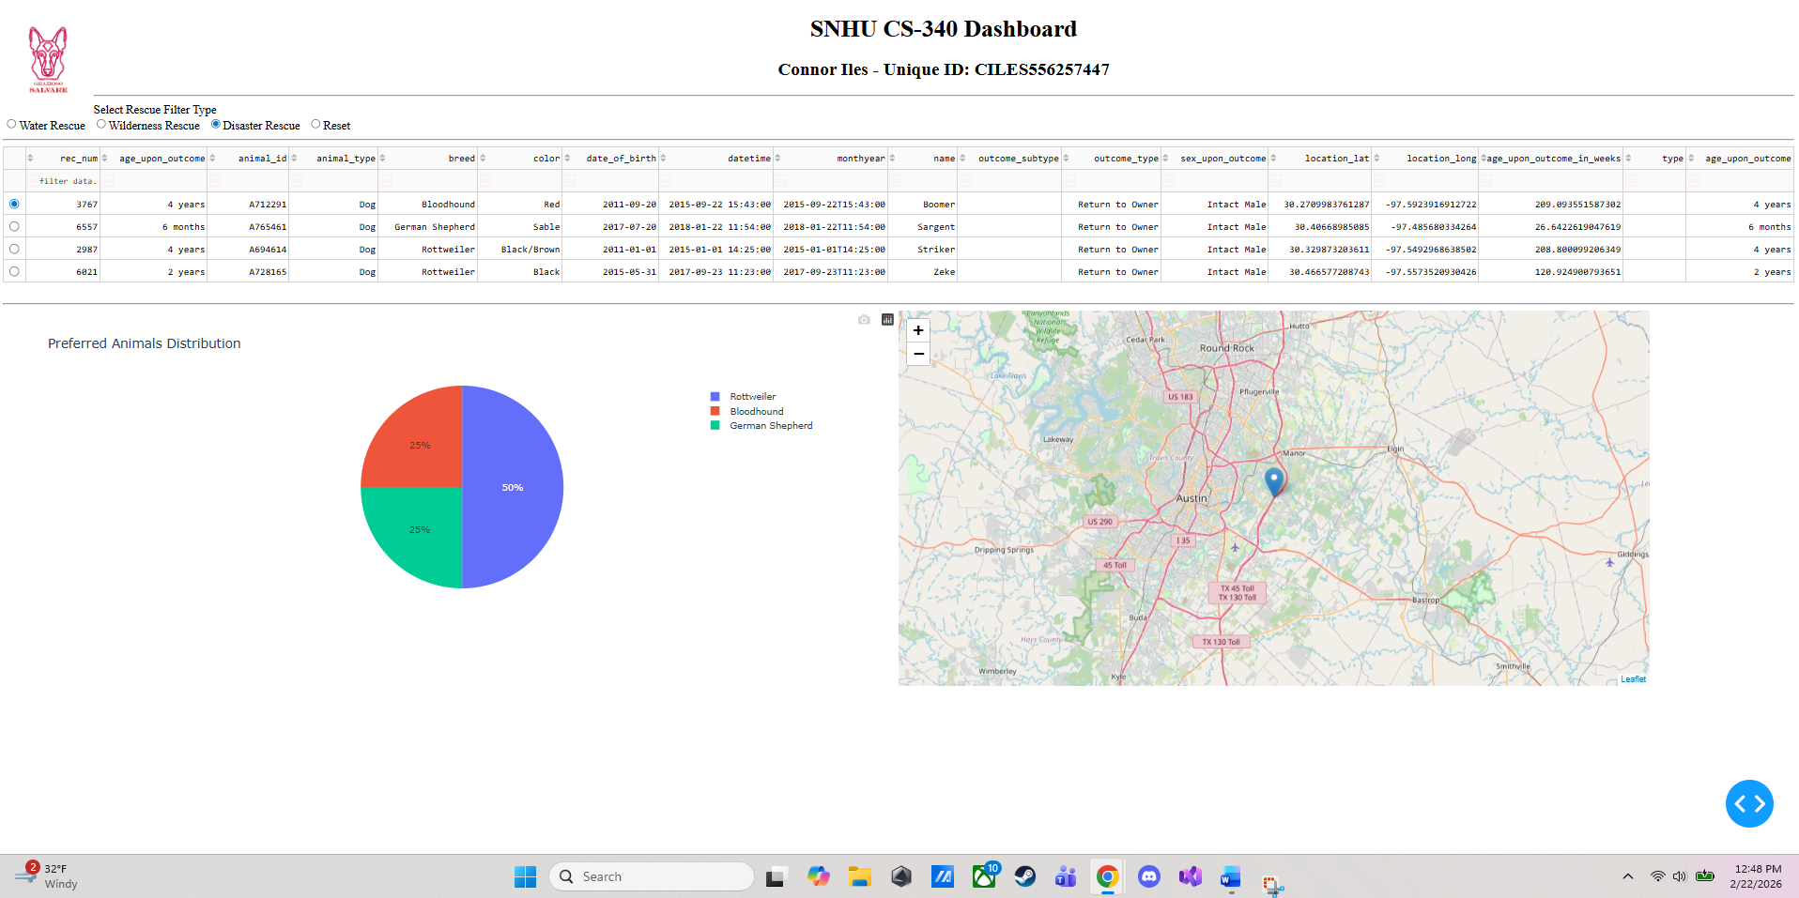
Tools & Rationale:
MongoDB was used as the main model. This was used as it is a NoSQL database, which is ideal for records such as those from a animal shelter, where there are varying records and data based on breed, ago, etc. the PyMongo driver ensures seamless integration with Python, changing BSON documents to Python Dictionaries.
The Dash framework by Plotly was used for the view and controller structure. Dash allows HTML and DCC to enhance the user interface with basic coding knowledge/principles. Dash’s callback mechanismis the main controller, as it manages the logic which updates the table and the charts seen in the Dashboard above.
Resources I used for this include:
https://dash.plotly.com/
https://www.dash-leaflet.com/
https://pandas.pydata.org/docs/
Steps that were taken to complete the project:
The first step was database setup which was done using MongoDB and importing the CSV files containing all data from the Austin Animal Center.
Next was CRUD development, where I built a Python class to handle create, read, update, and delete functions.
Then came designing the Dashboard which was done using Dash, the Grazioso Salvare logo was included in the dashboard.
Also, callback logic using python functions was applied by using radio buttons for filtering table results.
Finally, testing was done to ensure the data table updated based on filter choices and that geolocation data updated when an individual animal was selected.
Challenges Encountered:
One thing that hung me up was trying to load the logo. I thought that I had to map it by saying “look in the code_files folder” but we were already there so python was confused.
Also, I found I had a lot of typing errors, the biggest one was I had “age_upon_putcome” instead of “outcome” this bust’ve been from loading the DB in Mongo DB, I fixed this by using df.rename(columns={'age_upon_putcome': 'age_upon_outcome'}, inplace=True)
I also faced indentation issues mainly with callbacks, as I had callbacks nested in others which is why my pie chart did not originally populate and I was very confused.

